As of my last knowledge update in January 2022, I can provide you with some emerging technologies that are commonly employed in research centers. However, keep in mind that technology evolves rapidly, and there may be newer advancements since then. Here are some technologies that are often utilized in research centers:

1. **Artificial Intelligence (AI) and Machine Learning (ML):** AI and ML are used in various research applications, including data analysis, pattern recognition, and predictive modeling. They can assist in processing large datasets and identifying complex patterns.

2. **Blockchain:** Blockchain technology offers secure and transparent data storage and management, which can be beneficial in areas such as secure data sharing, supply chain management, and maintaining the integrity of research data.

3. **Internet of Things (IoT):** IoT devices collect and exchange data, providing valuable insights in research settings. In research centers, IoT can be used for environmental monitoring, equipment tracking, and real-time data collection.

4. **Big Data Analytics:** Research centers often deal with massive datasets. Big data analytics tools and frameworks help process and analyze large volumes of data to extract meaningful insights and trends.

5. **Cloud Computing:** Cloud platforms provide scalable and on-demand access to computing resources, facilitating collaborative research, data storage, and analysis without the need for significant on-site infrastructure.

6. **Augmented Reality (AR) and Virtual Reality (VR):** AR and VR technologies enhance visualization and simulation capabilities, enabling researchers to interact with data in new ways. They are used in fields such as healthcare, engineering, and education.

7. **5G Technology:** The rollout of 5G networks enhances connectivity and communication speeds, which can be crucial for real-time data transmission, remote collaboration, and the development of applications requiring high bandwidth.

8. **Biotechnology Advances:** In the life sciences, advancements in biotechnology, such as CRISPR gene editing, personalized medicine, and synthetic biology, are continually shaping research methodologies and outcomes.

9. **Robotics and Automation:** Robotics and automation technologies are employed in laboratories for tasks such as sample handling, repetitive experiments, and high-throughput screening.

10. **Quantum Computing:** Although still in the early stages, quantum computing has the potential to revolutionize computational capabilities, addressing complex problems that are currently intractable for classical computers.

11. **Cybersecurity Solutions:** As research centers handle sensitive data, robust cybersecurity measures, including encryption, threat detection, and secure data storage, are essential to protect against cyber threats.

When considering the adoption of new technologies in a research center, it's crucial to align the choice of technology with the specific goals, requirements, and nature of the research being conducted. Regularly staying updated on emerging technologies and their applications in relevant fields is also important.

Certainly! Below is a sample structure for a research report. Keep in mind that the content and format can vary depending on the specific requirements of your research, field of study, and the guidelines provided by your institution. Adjust the headings, subheadings, and content to fit your research project.

---

# Title: [Your Research Title]

## Abstract

Provide a concise summary of your research, including the objectives, methods, key findings, and conclusions. Aim for around 150-250 words.

## 1. Introduction

### 1.1 Background

Offer a brief overview of the background and context of your research, highlighting the significance of the study.

### 1.2 Research Problem

Clearly state the research problem or question that your study addresses.

### 1.3 Objectives

Outline the specific objectives or goals of your research.

## 2. Literature Review

Survey the relevant literature related to your research topic. Highlight key theories, methodologies, and findings from existing studies. Identify gaps in the current knowledge that your research aims to fill.

## 3. Methodology

### 3.1 Research Design

Explain the overall design of your study (e.g., experimental, observational, survey, case study).

### 3.2 Participants (or Sample)

Describe the characteristics of the participants or sample, including any relevant demographic information.

### 3.3 Data Collection

Detail the methods and instruments used to collect data. Include information on surveys, interviews, experiments, or any other relevant techniques.

### 3.4 Data Analysis

Describe the statistical or qualitative methods used to analyze the collected data.

## 4. Results

Present the main findings of your study. Use tables, charts, or graphs as needed for clarity. Provide a clear and objective summary of the results.

## 5. Discussion

### 5.1 Interpretation of Results

Discuss the implications of your findings and their significance in relation to your research objectives.

### 5.2 Comparison with Previous Studies

Compare your results with those of previous studies. Discuss similarities, differences, and possible explanations.

### 5.3 Limitations

Acknowledge any limitations in your study and suggest areas for future research.

## 6. Conclusion

Summarize the main points of your study and restate its importance. Highlight the contributions of your research and propose avenues for further exploration.

## 7. References

Provide a complete list of all the sources cited in your report, following a standardized citation style (e.g., APA, MLA, Chicago).

## 8. Appendices

Include any supplementary materials such as raw data, questionnaires, or additional supporting information.

---

Adapt this structure and content based on the specific requirements of your research project and the guidelines provided by your academic institution.

**of Fruit: Nutrition Profiles and Health Benefits**

[**Facebook1.5k**](https://www.facebook.com/sharer/sharer.php?u=https://www.nutritionadvance.com/healthy-foods/types-of-fruit/&display=popup&ref=plugin&src=share_button)[**Tweet**](https://twitter.com/share?url=https://www.nutritionadvance.com/healthy-foods/types-of-fruit/&text=54%20Types%20of%20Fruit%3A%20Nutrition%20Profiles%20and%20Health%20Benefits)[**Pin3.1k**](https://pinterest.com/pin/create/button/?url=https://www.nutritionadvance.com/healthy-foods/types-of-fruit/&media=https://www.nutritionadvance.com/wp-content/uploads/2017/12/types-of-fruit-nutritional-profiles-health-benefits.jpg&description=54%20Types%20of%20Fruit:%20Nutrition%20Profiles%20and%20Health%20Benefits)[**Email54**](https://www.nutritionadvance.com/healthy-foods/types-of-fruit/#shared-counts-email)[**Print**](javascript:window.print())

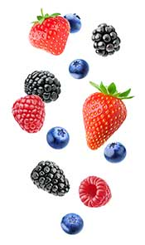

There are hundreds of types of fruit in the world, and they are [popular foods](https://www.nutritionadvance.com/types-of-food/) in almost every culture.

In this article, we’ll take a closer look at 54 of them.

Some are common, and maybe you won’t recognize some of the more unique varieties.

So, if you’ve ever wondered what specific nutrients a fruit has, the amount of carbohydrates it contains, or some random trivia – you’ll find it all here.

Use the menu below if you want to jump to a specific fruit, otherwise just keep reading.

**Types of Fruit – A to Z Quick Jump**

[**A**](https://www.nutritionadvance.com/healthy-foods/types-of-fruit/#tab-con-37)[**B**](https://www.nutritionadvance.com/healthy-foods/types-of-fruit/#tab-con-33)[**C**](https://www.nutritionadvance.com/healthy-foods/types-of-fruit/#tab-con-8)[**D**](https://www.nutritionadvance.com/healthy-foods/types-of-fruit/#tab-con-3)[**E**](https://www.nutritionadvance.com/healthy-foods/types-of-fruit/#tab-con-13)[**F**](https://www.nutritionadvance.com/healthy-foods/types-of-fruit/#tab-con-5)[**G**](https://www.nutritionadvance.com/healthy-foods/types-of-fruit/#tab-con-5)[**H**](https://www.nutritionadvance.com/healthy-foods/types-of-fruit/#tab-con-15)[**I**](https://www.nutritionadvance.com/healthy-foods/types-of-fruit/#tab-con-15)[**J**](https://www.nutritionadvance.com/healthy-foods/types-of-fruit/#tab-con-15)[**K**](https://www.nutritionadvance.com/healthy-foods/types-of-fruit/#tab-con-18)[**L**](https://www.nutritionadvance.com/healthy-foods/types-of-fruit/#tab-con-20)[**M**](https://www.nutritionadvance.com/healthy-foods/types-of-fruit/#tab-con-24)[**N**](https://www.nutritionadvance.com/healthy-foods/types-of-fruit/#tab-con-27)[**O**](https://www.nutritionadvance.com/healthy-foods/types-of-fruit/#tab-con-27)[**P**](https://www.nutritionadvance.com/healthy-foods/types-of-fruit/#tab-con-29)[**Q**](https://www.nutritionadvance.com/healthy-foods/types-of-fruit/#tab-con-40)[**R**](https://www.nutritionadvance.com/healthy-foods/types-of-fruit/#tab-con-40)[**S**](https://www.nutritionadvance.com/healthy-foods/types-of-fruit/#tab-con-44)[**T**](https://www.nutritionadvance.com/healthy-foods/types-of-fruit/#tab-con-46)[**U**](https://www.nutritionadvance.com/healthy-foods/types-of-fruit/#tab-con-48)[**V**](https://www.nutritionadvance.com/healthy-foods/types-of-fruit/#tab-con-49)[**W**](https://www.nutritionadvance.com/healthy-foods/types-of-fruit/#tab-con-49)

**1. Apple**

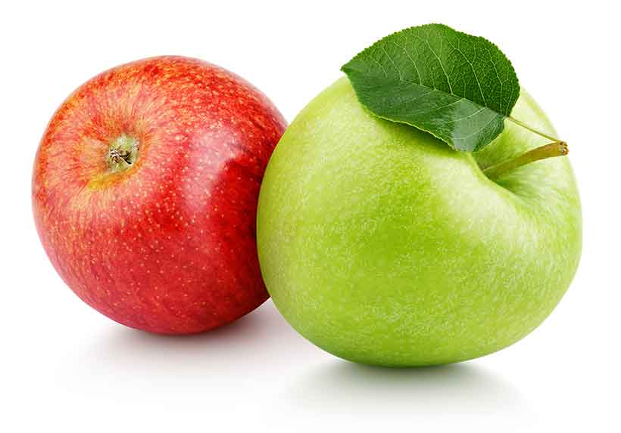

Apples are a sweet fleshy fruit that grow around the world.

Believed to originate in Central Asia, there are now hundreds of varieties of apples, ranging from sweet to sour.

Nutritionally speaking, apples are a relatively high-carbohydrate fruit and their most significant nutrient is vitamin C.

They’re a very versatile fruit; while often eaten as a snack, they’re also used in a variety of dessert recipes.

Per large apple, the nutrient profile looks like this ([1](http://nutritiondata.self.com/facts/fruits-and-fruit-juices/1810/2));

* **Calories:** 104 kcal
* **Carbohydrate:** 27.6 g
* **Fiber:**2.8 g
* **Sugar:** 21.8 g
* **Fat:** 0.3 g
* **Protein:**0.6 g
* **Vitamin C:** 14% RDA
* **Potassium:** 6% RDA
* **Manganese:** 4% RDA
* **Vitamin B6:** 4% RDA
* **Vitamin B2:** 4% RDA

Apples come in all shapes and sizes, from Granny Smith to Pink Lady and more.

On this note, see [this guide to all the apple varieties](https://www.nutritionadvance.com/types-of-apples/) for more information, and more specific nutritional data.

**2. Apricot**

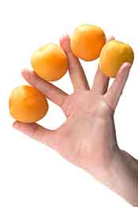

Sharing some resemblances to a peach, apricots are a small fleshy fruit that contain a hard stone (technically a seed) in the middle.

The apricot is a popular fruit with a light orange color and it is best known for its vitamin A and C content.

Apricots also provide various types of polyphenols, such as catechins.

Interestingly, apricots require a cold winter to grow properly, so they generally grow in countries experiencing a true four seasons.

Here are the nutritional values per apricot ([2](http://nutritiondata.self.com/facts/fruits-and-fruit-juices/1827/2));

* **Calories:** 16.8 kcal
* **Carbohydrate:** 3.9 g
* **Fiber:**0.7 g
* **Sugar:** 3.2 g
* **Fat:** 0.1 g
* **Protein:**0.5 g
* **Vitamin A:** 13% RDA
* **Vitamin C:** 6% RDA
* **Potassium:** 3% RDA
* **Vitamin E:** 2% RDA
* **Phosphorus:** 1% RDA

**3. Avocado**

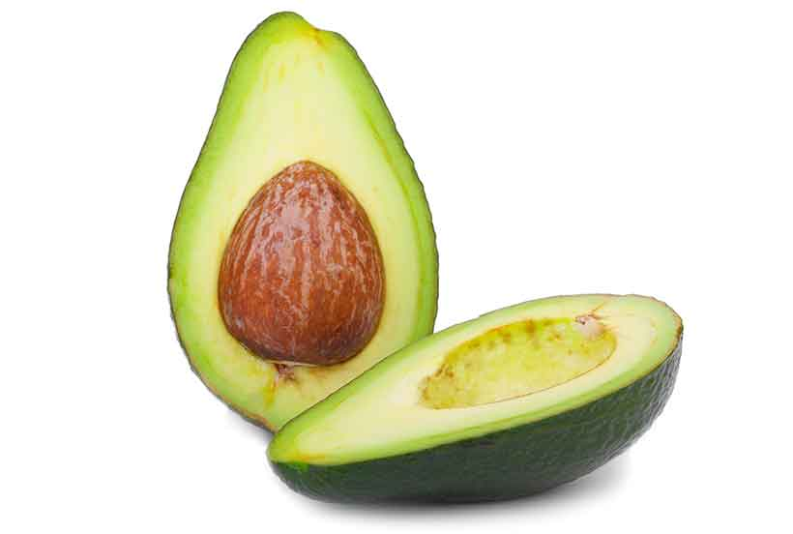

[Avocados](https://www.nutritionadvance.com/avocado-nutrition-benefits/) are an interesting fruit because they are very low in carbohydrate yet high in healthy fats.

The fruit originated in South America, possibly in Mexico or Peru, and it was first referred to in English by the name of “crocodile pear”.

One of the best things about the avocado is just how adaptable it is.

For instance, you may have heard of ‘avocado toast’, a trendy breakfast at the moment. However, there are many different ways to use avocados – such as making guacamole, avocado ice-cream, chocolate mousses, and many other interesting dishes.

Cold-pressed avocado oil also gives olive oil a run for its money in the ‘healthiest oil’ department; it’s a heat-stable fat that contains various protective nutrients.

Avocados are extremely nutrient-dense, and they are rich in fiber, protein, vitamins, and minerals – especially potassium.

Here is the nutrition breakdown per standard avocado ([3](http://nutritiondata.self.com/facts/fruits-and-fruit-juices/1843/2));

* **Calories:** 322 kcal
* **Carbohydrate:** 17.1 g
* **Fiber:**13.5 g
* **Sugar:** 0.2 g
* **Fat:** 29.5 g
* **Protein:**4 g
* **Vitamin K:** 53% RDA
* **Folate:** 41% RDA
* **Vitamin C:** 33% RDA
* **Potassium:** 28% RDA
* **Vitamin B5:** 28% RDA

**4. Banana**



The banana is a tropical fruit with a long body covered in a yellow skin.

It’s a very common fruit and—despite needing a hot climate—it’s available in most countries.

Since bananas have a very sweet taste, dessert recipes often use them.

In particular, banana splits, banana milk, and banana bread are some of the most popular options.

Due to their accessibility and inexpensive price, bananas are one of the most popular types of fruit in the world.

One medium banana has the following nutrient profile ([4](http://nutritiondata.self.com/facts/fruits-and-fruit-juices/1846/2));

* **Calories:** 105 kcal
* **Carbohydrate:** 27.0 g
* **Fiber:**3.1 g
* **Sugar:** 14.4 g
* **Fat:** 0.4 g
* **Protein:**1.3 g
* **Vitamin B6:** 22% RDA
* **Vitamin C:** 17% RDA
* **Manganese:** 16% RDA
* **Potassium:** 12% RDA
* **Magnesium:** 8% RDA

[See here](https://www.nutritionadvance.com/bananas-nutrition-benefits/) for a full guide to the nutritional benefits of bananas.

Also, [this nutritional guide to plantains](https://www.nutritionadvance.com/plantains-nutrition-benefits/) takes a look at the closely-related fruit.

**5. Blackberries**

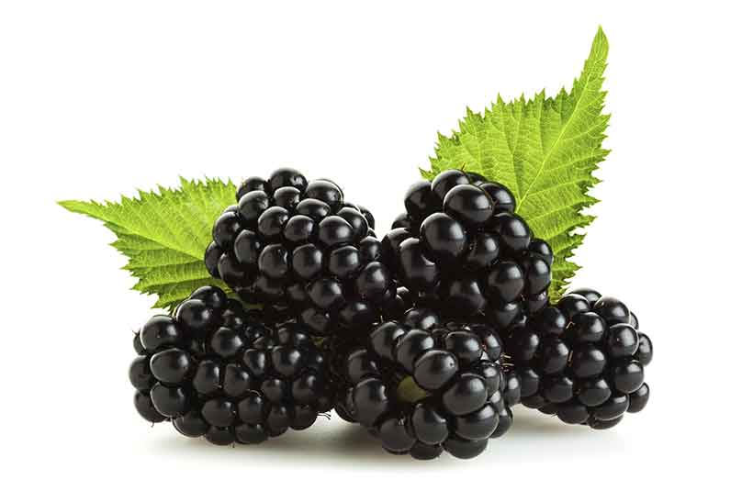

[Blackberries](https://www.nutritionadvance.com/blackberries-nutrition-benefits/) are one of the tastiest fruits around.

They are a small edible fruit with a big taste, and botanically they are a kind of berry that grow on brambles. The fruit has a sweet and succulent taste despite being relatively low in fructose compared to most types of fruit.

Blackberries are one of the most commonly cultivated fruits. However, we can also find them growing in their wild state – which purportedly have a better nutritional profile and more polyphenols ([5](http://www.tandfonline.com/doi/full/10.1080/13102818.2016.1204943)).

Combine them with some fresh cream for a delicious, sweet and creamy dessert.

Blackberries are especially good for vitamin C and the health benefits it provides.

Nutritionally, here is what blackberries look like per 100g ([6](http://nutritiondata.self.com/facts/fruits-and-fruit-juices/1848/2));

* **Calories:** 43 kcal
* **Carbohydrate:** 10.2 g
* **Fiber:**5.3 g
* **Sugar:** 4.9 g
* **Fat:** 0.5 g
* **Protein:**1.4 g
* **Vitamin C:** 35% RDA
* **Manganese:** 32% RDA
* **Vitamin K:** 25% RDA
* **Copper:** 8% RDA
* **Vitamin E:** 6% RDA

**6. Blackcurrant**

Black currants are a common fruit found in Europe.

Since blackcurrants have a sour and tart flavor, they are often sweetened prior to consumption.

Due to their availability and popular flavor, they are used as a culinary fruit in cooking – and in the development of various products.

In fact, they are one of the most commercially successful types of fruit, and it’s easy to see blackcurrant candy, juice, soda, tea, and so on.

Per 100g, blackcurrants provide a substantial amount of vitamin C; here is the full macro and micronutrient profile ([7](https://fdc.nal.usda.gov/fdc-app.html#/food-details/173963/nutrients));

* **Calories:** 63 kcal
* **Carbohydrate:** 15.4 g
* **Fiber:**–
* **Sugar:** –
* **Fat:**0.4 g
* **Protein:**1.4 g
* **Vitamin C:** 201% RDA
* **Vitamin K:** 25% RDA
* **Manganese:** 11% RDA
* **Potassium:** 9% RDA
* **Copper:** 10% RDA

[See this full guide to black currants and their nutritional benefits](https://www.nutritionadvance.com/black-currants/) for more information.

**7. Blueberries**

Lauded for their purported health benefits, [blueberries](https://www.nutritionadvance.com/wild-blueberries-nutrition-benefits/) are a fruit that just about everyone considers healthy.

They are certainly rich in health-protective polyphenols, and they offer a decent selection of vitamins and minerals too.

With a deep blue color, they are also attractive in their appearance.

On a positive note, research studies demonstrate that blueberries may lower high blood pressure and improve cardiovascular risk factors ([8](https://www.ncbi.nlm.nih.gov/pubmed/27654329), [9](https://www.ncbi.nlm.nih.gov/pmc/articles/PMC4804301/)).

Blueberries are somewhat low in carbohydrate too, putting them near the top of the low carb list of fruits.

Here’s their nutritional breakdown per 100g ([10](http://nutritiondata.self.com/facts/fruits-and-fruit-juices/1851/2));

* **Calories:** 57 kcal
* **Carbohydrate:** 14.5 g
* **Fiber:**2.4 g
* **Sugar:** 10 g
* **Fat:** 0.3 g
* **Protein:**0.7 g
* **Vitamin K:** 24% RDA
* **Manganese:** 17% RDA
* **Vitamin C:** 16% RDA
* **Vitamin B6:** 3% RDA
* **Vitamin E:** 3% RDA

**8. Boysenberries**

[Boysenberries](https://www.nutritionadvance.com/boysenberries-nutrition-benefits/) are a cross between blackberries, dewberries, loganberries, and raspberries.

Perhaps the best characteristic of this large berry is how juicy and refreshing it is; boysenberries grow to a large size and contain around 88% water by weight.

They have a delicious flavor too, and they offer a fairly impressive nutrition profile. Here are their basic nutritional values;

* **Calories:**43 kcal
* **Carbohydrate:**9.6 g
* **Fiber:**5.3 g
* **Sugar:**4.3 g
* **Fat:**0.5 g
* **Protein:**1.4 g
* **Vitamin C:**35% RDA
* **Manganese:**32% RDA
* **Vitamin K:**25% RDA
* **Copper:**8% RDA
* **Vitamin E:**7% RDA

**9. Capers**

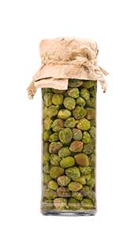

You may not know it, but [capers](https://www.nutritionadvance.com/what-are-capers/) are actually a category of fruit.

Typically served alongside salmon and horseradish sauce, capers are a pea-sized green fruit native to parts of the Mediterranean and Asia.

Botanically speaking, capers are flower buds from the caper bush; they are picked and then pickled.

As a result, capers have a sharp and salty taste due to the lengthy amount of time in brine.

However, the taste is very unique and interesting, and capers are very flavorful.

The contrasting flavors match particularly well with fish, which is probably why they’re often served with salmon.

In terms of nutrition, here’s a rundown per ounce (28g) serving ([11](http://nutritiondata.self.com/facts/spices-and-herbs/222/2));

* **Calories:** 6.4 kcal
* **Carbohydrate:** 1.4 g
* **Fiber:**0.9 g
* **Sugar:** 0.1 g
* **Fat:** 0.2 g
* **Protein:**0.7 g
* **Vitamin K:** 9% RDA
* **Copper:** 5% RDA
* **Iron:** 3% RDA
* **Magnesium:** 2% RDA
* **Folate:** 2% RDA

**10. Cherimoya**

Cherimoya is one of the most unique-looking fruits, and it has a great taste and a decent nutritional profile too.

It is an exotic fruit with a sweet and creamy taste.

Per 100 grams, cherimoya provides ([12](https://fdc.nal.usda.gov/fdc-app.html#/food-details/173953/nutrients)):

* **Calories:**75 kcal
* **Carbohydrate:**17.7 g
* **Fiber:**3.0 g
* **Sugar:**12.9 g
* **Fat:**0.7 g
* **Protein:**1.6 g

For a complete nutritional guide to cherimoya, see here:

[What Is Cherimoya? Nutrition, Benefits, and More](https://www.nutritionadvance.com/what-is-cherimoya/)

**11. Cherry**

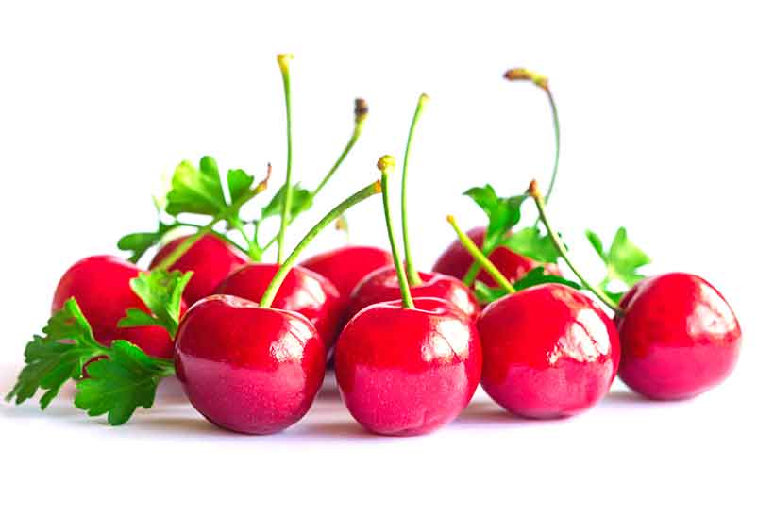

[Cherries](https://www.nutritionadvance.com/cherries-nutrition-benefits/) are one of the most popular fruit varieties, and they are technically a drupe – a fruit with a hard stone inside.

The cherry is a small fruit with a sweet and juicy taste. There are also two main types of cherry; sour cherries and sweet cherries.

These two varieties are fairly similar, but sour cherries have the slightly better nutritional profile.

Sour cherries predominantly grow in Russia, Eastern Europe and Southern Asia.

On the other hand, Turkey and the United States are the biggest producers of sweet cherries.

All cherries are varying shades of red; see [this guide to red fruit](https://www.nutritionadvance.com/red-fruits/) to learn more about what gives fruit this red pigmentation.

Cherries are a seasonal fruit, but frozen cherries are available around the year.

Learn more about the key differences between fresh and frozen fruit and vegetables here:

[Fresh vs. Frozen Fruit & Vegetables: Which Is Better Nutritionally?](https://www.nutritionadvance.com/fresh-vs-frozen-fruit-and-vegetables/)

Per 100g, here are the nutritional values of sour cherries ([13](http://nutritiondata.self.com/facts/fruits-and-fruit-juices/1861/2));

* **Calories:** 50 kcal
* **Carbohydrate:** 12.2 g
* **Fiber:**1.6 g
* **Sugar:** 8.5 g
* **Fat:** 0.3 g
* **Protein:**1.0 g
* **Vitamin A:** 26% RDA
* **Vitamin C:** 17% RDA
* **Manganese:** 6% RDA
* **Potassium:** 5% RDA
* **Copper:** 5% RDA

**12. Black Chokeberry**

Otherwise known as Aronia berries, black chokeberries are an acquired taste.

The reason for this is simple; they’re one of the most bitter-tasting foods in existence!

However, they’re among the healthiest of fruit and contain an impressive range of polyphenols.

To be precise, they are the [7th biggest provider of polyphenols](https://nutritionadvance.com/nutrition/top-food-sources-polyphenols/) among all foods.

Due to their bitter taste, it’s not uncommon to find chokeberries in various sweetened foods like jam and juices. Additionally, various chokeberry wines and teas are available.

Concerning their nutritional profile, chokeberries provide the following per 100g ([14](http://nutritiondata.self.com/facts/custom/3081828/2));

* **Calories:** 47 kcal
* **Carbohydrate:** 9.6 g
* **Fiber:**5.3 g
* **Sugar:** 4.3 g
* **Fat:** 0.5 g
* **Protein:**1.4 g
* **Vitamin C:** 35% RDA
* **Manganese:** 32% RDA
* **Vitamin K:** 17% RDA
* **Iron:** 8% RDA
* **Vitamin E:** 8% RDA

**13. Cranberry**

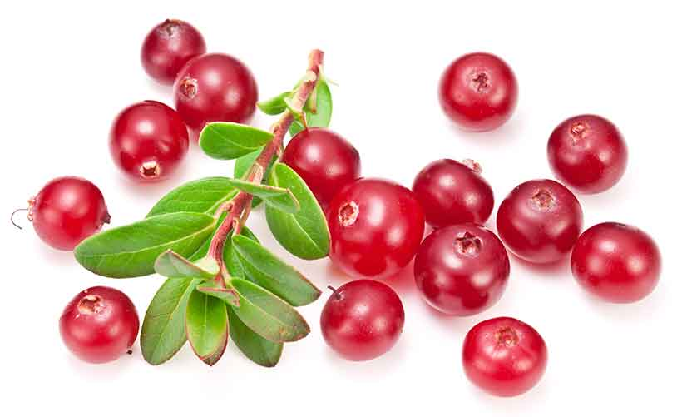

[Cranberries](https://www.nutritionadvance.com/cranberry-fruit-nutrition-benefits/) are a small edible berry with a bright red color.

They’re a very popular commercial fruit, and they feature in all sorts of processed food products such as juice, jam, jelly, and more.

Due to their sour nature, they are usually available in their dried form and contain added sugar.

However, it is possible to find fresh berries, but they are very tart.

Similar to chokeberries, they contain large amounts of phytonutrients, and these compounds tend to be very bitter or sour in nature.

Nutritionally, cranberries are a decent source of vitamin C per 100g ([15](http://nutritiondata.self.com/facts/fruits-and-fruit-juices/1875/2));

* **Calories:** 46 kcal
* **Carbohydrate:** 12.2 g
* **Fiber:** 4.6 g
* **Sugar:** 4.0 g
* **Fat:** 0.1 g
* **Protein:**0.4g
* **Vitamin C:** 22% RDA
* **Manganese:** 6% RDA
* **Vitamin E:** 4% RDA
* **Vitamin K:** 4% RDA
* **Copper:** 4% RDA

**14. Date Palm**

Date Palm, often simply referred to as ‘date’, is a sweet edible fruit believed to originate from the Middle East region.

The date fruit tree, upon which the fruits grow, has a tropical look and—surprisingly—one single tree produces hundreds of pounds of fruit per year.

People commonly eat the fruit in fresh and dried form.

Notably, dates are one of the sweetest types of fruit available, and they have exceptionally high sugar content.

On that note, the dried form of the fruit is extremely sweet, so it’s not a good idea for those on lower carb diets.

Here are the nutrients that four pitted dates provide ([16](http://nutritiondata.self.com/facts/fruits-and-fruit-juices/7348/2));

* **Calories:** 66.5 kcal
* **Carbohydrate:** 72 g
* **Fiber:**6.4 g
* **Sugar:** 64 g
* **Fat:** 0 g
* **Protein:**0.4 g
* **Potassium:** 5% RDA
* **Copper:** 4% RDA
* **Manganese:** 4% RDA
* **Magnesium:** 3% RDA
* **Vitamin B6:** 3% RDA

**Dried Fruit**

While not a specific variety of fruit, it is worth pointing out that there are numerous varieties of dried fruit.

These dried fruit options have slightly different characteristics from fresh fruit, but they can still provide a good range of beneficial nutrients.

See these articles for more information:

[Is Dried Fruit a Healthy Choice?](https://www.nutritionadvance.com/is-dried-fruit-a-healthy-choice/)

[24 Types of Dried Fruit and Their Nutritional Values](https://www.nutritionadvance.com/types-of-dried-fruit/)

**15. Durian**

Known for its peculiar scent, the durian is a giant-sized tropical fruit that’s native to South-East Asia.

If you have ever seen a jackfruit, the durian shares a similar appearance—only it’s much larger in size.

Durian is a popular culinary fruit and it commonly features in a variety of Thai, Malaysian and Indonesian dishes – both sweet and savory.

By “peculiar” scent, what I really mean is “bad”. There are various words to describe this smell, but perhaps the most telling one is “smells like a gym sock.”

On the other hand, the taste is pretty good – sweet, creamy, and kind of nutty.

Durians have an interesting nutritional profile too. In fact, they are one of the only fruits to contain a decent amount of carbohydrates **and** fat.

Per 100g, the durian supplies ([17](http://nutritiondata.self.com/facts/fruits-and-fruit-juices/2088/2));

* **Calories:** 147 kcal
* **Carbohydrate:** 27.1g
* **Fiber:**3.8 g
* **Sugar:** –
* **Fat:** 5.3 g
* **Protein:**1.5 g
* **Vitamin C:** 14% RDA
* **Vitamin B1:** 6% RDA
* **Vitamin B6:** 4% RDA
* **Manganese:** 4% RDA
* **Potassium:** 4% RDA

See this [complete guide to durian fruit](https://www.nutritionadvance.com/what-is-durian-fruit/) for more information.

**16. Elderberry**

The elderberry is a small blue-to-black fruit that grows around the world.

It is also one of the most bitter types of fruit you will come across.

Due to the astringent taste, most people consume the berries as jams, teas, juices, syrup, and other elderberry products.

Elderberry bushes are easy to cultivate, and they produce thousands of berries each year.

Nutritionally speaking, elderberries are rich in polyphenols (hence their bitter taste) and a great source of vitamin C.

Here is their full profile per 100g serving ([18](http://nutritiondata.self.com/facts/fruits-and-fruit-juices/1883/2));

* **Calories:** 73 kcal
* **Carbohydrate:** 18.4 g
* **Fiber:**7 g
* **Sugar:** –
* **Fat:** 0.5 g
* **Protein:**0.7 g
* **Vitamin C:** 60% RDA
* **Vitamin A:** 12% RDA
* **Vitamin B6:** 11% RDA
* **Iron:** 9% RDA
* **Potassium:** 8% RDA

**17. Goji Berries**

[Goji berries](https://www.nutritionadvance.com/goji-berries-nutrition/) are a small red fruit native to China and South-Eastern Europe. Traditionally used as a medicinal fruit, goji tea—steeped dried berries—is a common health drink for the Chinese.

Since China is the predominant source of these berries, it’s difficult to find goji berries in their fresh fruit form.

However, the dried form of the fruit has become increasingly popular in the West over the past decade.

This is partly due to the unusual but delicious taste the berries have; slightly sweet, a little bitter, chewy, and moreish.

Interestingly, goji berries are one of the only kinds of fruit to provide carbohydrates and protein. An ounce of dried berries provides around 4g protein (which equates to 14g per 100g).

Per ounce (28g) serving of the fruit, goji berries provide the following nutrients ([19](http://nutritiondata.self.com/facts/fruits-and-fruit-juices/2088/2));

* **Calories:** 98 kcal
* **Carbohydrate:** 22 g
* **Fiber:**3.6 g
* **Sugar:** 13 g
* **Fat:** 0.1 g
* **Protein:**4 g
* **Vitamin A:** 50% RDA
* **Copper:** 28% RDA
* **Selenium:** 25% RDA
* **Vitamin B2:** 21% RDA
* **Iron:** 14% RDA

**18. Golden Berries**

Golden berries are another dried form of fruit that has recently become popular.

However, the true name of the fruit is ‘Peruvian groundcherry’. As the name suggests, they are native to Peru—as well as other South American countries.

Often dubbed a ‘superfood’, the berries are trendy in healthy eating circles.

*(****Note:****it is best to take all ‘superfood’ claims with a liberal pinch of salt.)*

They have an incredibly sour taste, so give them a try if you’re one of those people who like eating a raw lemon.

Nutritionally, like most sour-tasting fruits, they provide a good source of vitamin C.

Per 100g, fresh Peruvian groundcherries supply ([20](http://nutritiondata.self.com/facts/fruits-and-fruit-juices/1926/2/));

* **Calories:** 53 kcal
* **Carbohydrate:** 11.2 g
* **Fiber:**–
* **Sugar:** –
* **Fat:** 0.7 g
* **Protein:**1.9 g
* **Vitamin C:** 18% RDA
* **Vitamin A:** 14% RDA
* **Vitamin B3:** 14% RDA
* **Vitamin B1:** 7% RDA
* **Iron:**6% RDA

**19. Gooseberries**

Gooseberries are delicious (but rather sour) berries that grow in numerous different countries around the world.

The berries only have a short picking season in the summer months, and their color can vary depending upon cultivar and level of ripeness.

Per 100 grams, gooseberries provide ([21](https://fdc.nal.usda.gov/fdc-app.html#/food-details/173030/nutrients)):

* **Calories:** 44 kcal
* **Carbohydrate:** 10.18 g
* **Fiber:**4.3 g
* **Sugar:** 5.4 g
* **Fat:** 0.6 g
* **Protein:**0.9 g
* **Vitamin C:** 31% RDA
* **Manganese:** 6% RDA
* **Vitamin B5:** 5% RDA
* **Vitamin B6:** 7% RDA
* **Potassium:**4% RDA

**20. Grape**

Grapes are one of the most prevalent types of fruit, and we can find them almost everywhere.

Grapes are very versatile too, and they form the basis of many different wines, juices, jams, and dessert products.

Not many people know this, but grapes are botanically a kind of berry. Although there are thousands of different grape varieties, they are typically classified as either white (green), red, purple, or black.

The health benefits of grapes are purported to come from their high polyphenol content. However, grapes are also one of the highest-sugar fruits.

As a result, red wine is often thought of as a health drink since it contains concentrated polyphenols and little sugar.

Nutritionally, 100g of fresh grapes provides ([22](http://nutritiondata.self.com/facts/fruits-and-fruit-juices/1920/2));

* **Calories:** 69 kcal
* **Carbohydrate:** 18.1 g
* **Fiber:**0.9 g
* **Sugar:** 15.5 g
* **Fat:** 0.2 g
* **Protein:**0.7 g
* **Vitamin C:** 18% RDA
* **Vitamin K:** 18% RDA
* **Vitamin B1:** 5% RDA
* **Potassium:** 5% RDA
* **Manganese:** 4% RDA

**21. Grapefruit**

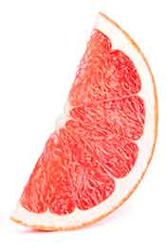

Grapefruit is a large citrus fruit believed to originate in Asia.

It is actually a hybrid fruit, which means that it is not an original species; it was created by the natural crossing of an orange and a pomelo.

Grapefruit has a slightly bitter, sour, but a little bit sweet taste. There are also different varieties of the fruit, ranging from white to pink and red.

All grapefruit are relatively high in polyphenols, notably flavonoids such as naringinen.

Their vitamin and mineral profile is dominated by vitamin C, and a one cup (230g) serving provides ([23](http://nutritiondata.self.com/facts/fruits-and-fruit-juices/1905/2));

* **Calories:** 96 kcal
* **Carbohydrate:** 24.5 g
* **Fiber:**3.7 g
* **Sugar:** 15.8 g
* **Fat:** 0.3 g
* **Protein:**1.8 g
* **Vitamin C:** 120% RDA
* **Vitamin A:** 53% RDA
* **Potassium:** 9% RDA
* **Vitamin B1:** 7% RDA
* **Folate:** 7% RDA

**22. Guava**

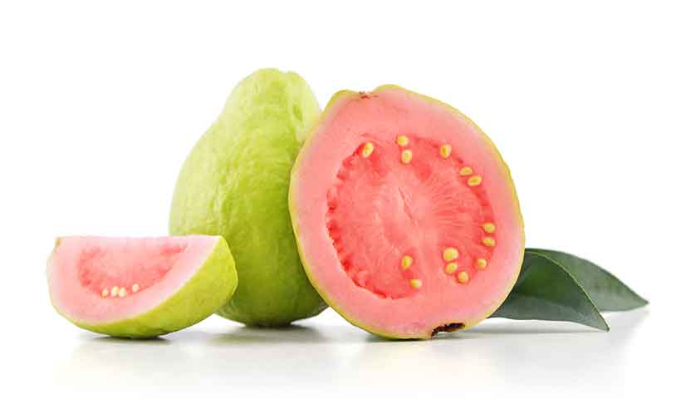

Guava is a tropical fruit that grows in tropical and subtropical areas.

Generally speaking, we can find it in Mexico and elsewhere in Central and Southern America.

Guava has an interesting appearance and it has a lime-green skin with a pink fleshy center. Depending on the ripeness of the fruit, guavas may taste anything from slightly sour to sweet.

Hint: as guava ripens, its green skin will slowly turn to a light yellow color. If you want sweeter tasting guava, go for one which has tinges of yellow on its skin.

Also, for more on yellow pigmentation in fruit, see this guide to yellow fruits:

[A List of 16 Yellow Fruits & Their Nutritional Benefits](https://www.nutritionadvance.com/yellow-fruits/)

Nutritionally, guavas are an exceptional provider of vitamin C – just one small fruit supplies 209% of the RDA.

Per fruit, the full nutritional breakdown looks like this ([24](http://nutritiondata.self.com/facts/fruits-and-fruit-juices/1927/2));

* **Calories:** 37.4 kcal
* **Carbohydrate:** 7.9 g
* **Fiber:**3.0 g
* **Sugar:** 4.9 g
* **Fat:** 0.5 g
* **Protein:**1.4 g
* **Vitamin C:** 209% RDA
* **Vitamin A:** 7% RDA
* **Folate:** 7% RDA
* **Potassium:** 7% RDA
* **Copper:**6% RDA

**23. Jackfruit**

[Jackfruit](https://www.nutritionadvance.com/what-is-jackfruit/) grows in tropical regions throughout the world, but it is believed to have originated in India.

Jackfruit has a unique name, and the fruit has an interesting appearance too. It looks somewhat like a giant version of an avocado and it is the largest tree fruit in the world.

In fact, one fruit can weigh as much as 35kg; imagine carrying that one home! This tropical fruit is said to taste incredible, with a soft and sweet peach-colored flesh waiting inside.

The consensus is that the fruit has a unique taste, and it has drawn comparisons to all sorts of flavors. For instance, these comparisons range from pineapple and mango to potatoes and—surprisingly—pulled pork.

Per cup, jackfruit provides various macro and micronutrients including ([25](http://nutritiondata.self.com/facts/fruits-and-fruit-juices/1930/2));

* **Calories:** 155 kcal
* **Carbohydrate:** 39.6 g
* **Fiber:**2.6 g
* **Sugar:** –
* **Fat:** 0.5 g
* **Protein:**2.4 g
* **Vitamin C:** 18% RDA
* **Manganese:** 16% RDA
* **Magnesium:** 15% RDA
* **Copper:** 15% RDA
* **Potassium:** 14% RDA

**24. Jujube**

Jujube is otherwise known as a ‘Chinese date’ and it has been cultivated in China for centuries.

Playing a significant role in traditional Chinese medicine, people have historically believed it to have many powerful effects including anti-bacterial, anti-inflammatory, and contraceptive properties.

In terms of real scientific research, some studies suggest that it may be a viable treatment for chronic constipation ([26](https://www.karger.com/Article/Abstract/190975)).

We can eat jujube either fresh, dried, or in many different processed products such as jujube tea.

Jujube has a sweet and juicy taste when fresh, and this sweetness strengthens in their dried state.

100g of fresh jujube provides the following nutrition ([27](http://nutritiondata.self.com/facts/fruits-and-fruit-juices/1932/1));

* **Calories:** 79 kcal
* **Carbohydrate:** 20.2 g
* **Fiber:**–
* **Sugar:** –
* **Fat:** 0.2 g
* **Protein:**1.2 g
* **Vitamin C:** 115% RDA
* **Potassium:** 7% RDA
* **Copper:** 6% RDA
* **Vitamin B6:** 6% RDA
* **Manganese:** 6% RDA

**25. Juniper Berries**

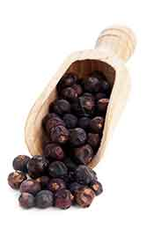

Juniper berries are not technically a real berry/fruit, but they are often classified as one.

Typically, juniper berries feature as a spice in various dishes, and they are also behind the flavor of gin.

Although juniper berries—when fresh—look a little like blueberries, they taste completely different.

They have a bitter woody feel; slightly fruity, spicy, and a little peppery. Owing to their flavor, they are a regular choice for flavoring and seasoning various soups and meat-based dishes.

However, the flavor is intense so only a little is necessary — usually around one gram. As a result, the nutrients such a small amount provides are negligible.

**26. Kiwi**

Kiwifruit is a soft, green and juicy edible fruit.

It has the alternate name of ‘Chinese gooseberry’ and it is one of the most famous types of fruit in the world.

The fruit is relatively easy to grow and it’s easy to find in most developed countries.

Kiwifruit taste slightly sour, but mostly sweet, and their green flesh and black seeds are encased in an olive-colored furry skin.

Kiwis contain an impressive amount of vitamin C. Notably, one small fruit contains more than the daily RDA.

Here are the nutritional details for one small kiwi ([28](http://nutritiondata.self.com/facts/fruits-and-fruit-juices/1934/2));

* **Calories:** 46.4 kcal
* **Carbohydrate:** 11.1 g
* **Fiber:**2.3 g
* **Sugar:** 6.8 g
* **Fat:** 0.4 g
* **Protein:**0.9 g
* **Vitamin C:** 117% RDA
* **Vitamin K:** 38% RDA
* **Potassium:** 7% RDA
* **Vitamin E:** 6% RDA
* **Copper:** 4% RDA

**27. Kumquat**

Kumquats are a type of citrus fruit that share lots of similarities with oranges.

However, they are much smaller and you can eat them whole in one go.

Their taste is quite different to the sweet taste of oranges too; specifically, kumquats have a very tart flesh.

However, the rind is somewhat sweet, so the fruit has a contrast of sweet and sour flavors.

This small citrus fruit now grows around the world, but it is native to South Asia.

Similar to other citrus fruits, kumquats provide a large amount of vitamin C. Per 3oz (85g) serving, kumquats provide ([29](http://nutritiondata.self.com/facts/fruits-and-fruit-juices/1935/2));

* **Calories:** 57 kcal
* **Carbohydrate:** 13.5 g
* **Fiber:**5.4 g
* **Sugar:** 7.8 g
* **Fat:** 0.6 g
* **Protein:**0.5 g
* **Vitamin C:** 60% RDA
* **Vitamin A:** 6% RDA
* **Calcium:** 6% RDA
* **Manganese:** 6% RDA
* **Magnesium:** 3% RDA

[See this full guide to kumquat fruit for more information](https://www.nutritionadvance.com/kumquat/)

**28. Lemon**

If you like sour fruits, then here’s another – the lemon is a yellow citrus fruit native to Asia.

Lemons house a tart soft flesh behind a thick yellow skin, and they are a famous culinary fruit. For one thing, thousands of recipes call for a squeeze of fresh lemon juice.

Lemons also hold value for cleaning uses; the reason for this is their high concentration of citric acid.

In addition, there is a wide variety of lemon-based food products, such as lemon cakes, lemon juice, lemon jam, and lemon tea.

Nutritionally speaking, the major compound in lemons is vitamin C. The fruit offers the following vitamins and minerals per standard-sized fruit ([30](http://nutritiondata.self.com/facts/fruits-and-fruit-juices/1936/2));

* **Calories:** 25.8 kcal
* **Carbohydrate:** 25.4 g
* **Fiber:**1.6 g
* **Sugar:** 1.5 g
* **Fat:** 0.2 g
* **Protein:**0.6 g
* **Vitamin C:** 51% RDA
* **Calcium:** 2% RDA
* **Potassium:** 2% RDA
* **Vitamin B1:** 2% RDA
* **Vitamin B6:** 2% RDA

**29. Lime**

Very close in nature to lemons, the lime is another sour citrus fruit.

However, they both have a slight difference in flavor – lemons are slightly more tart, while limes are bitter.

The flesh of both fruits looks very similar except for the color, and their nutritional profile and health benefits are fairly similar too.

There are many different types of lime species, and all are believed to have originated in Indonesia and South-Eastern Asia.

Similar to lemons, it is common to use limes for flavor in various drinks, cocktails, and teas.

Per medium-sized fruit, limes provide ([31](http://nutritiondata.self.com/facts/fruits-and-fruit-juices/1942/2));

* **Calories:** 31.3 kcal
* **Carbohydrate:** 7.1 g
* **Fiber:**1.9 g
* **Sugar:** 1.1 g
* **Fat:** 0.1 g
* **Protein:**0.5 g
* **Vitamin C:** 32% RDA
* **Potassium:**2% RDA
* **Calcium:** 2% RDA
* **Iron:** 2% RDA
* **Copper:** 2% RDA

**30. Longan Fruit**

[Longan is a tropical fruit](https://www.nutritionadvance.com/longan-fruit-nutrition-benefits/) that belongs to the soapberry family.

This botanical family also includes the slightly better-known lychee fruit and rambutan.

Due to the unique look of the fruit, the nickname of ‘dragon’s eye’ is common throughout China, where the fruit may have originated.

Longans are a brilliant white, with a big black seed, surrounded by an olive-brown skin.

Longan fruits have a soft and smooth texture inside their skin, and they are extremely juicy. The taste is very sweet, and the fruit plays a culinary role in many Asian dishes.

Nutritionally, a 100g serving provides ([32](http://nutritiondata.self.com/facts/fruits-and-fruit-juices/1948/2));

* **Calories:** 60 kcal
* **Carbohydrate:** 15.1 g
* **Fiber:**11.1 g
* **Sugar:** –
* **Fat:** 0.1 g
* **Protein:**0.3 g
* **Vitamin C:** 14% RDA
* **Potassium:** 8% RDA
* **Copper:** 8% RDA
* **Vitamin B2:** 8% RDA
* **Manganese:** 3% RDA

**31. Lychee**

The lychee is a tropical fruit almost identical in nature to rambutan and longan fruit.

For example, the flesh, nutritional profile, and flavor are all fairly similar.

However, the outer skin is the main difference. While longans have a light brown peel that looks like potato skin, lychees and rambutan have a textured reddish-purple outer peel.

Lychee are also slightly sweeter than longan fruit, but not as sweet as rambutan.

The history of the lychee goes back to the mid-11th century, and it originates in Guangdong, China. Like other types of fruit in the soapberry family, lychees provide a huge source of vitamin C.

Here is the complete profile of lychees per 100g ([33](http://nutritiondata.self.com/facts/fruits-and-fruit-Juices/1945/2));

* **Calories:** 66 kcal
* **Carbohydrate:** 16.5 g
* **Fiber:**1.3 g
* **Sugar:** 15.2 g
* **Fat:** 0.4 g
* **Protein:**0.8 g
* **Vitamin C:** 119% RDA
* **Copper:** 7% RDA
* **Vitamin B6:** 5% RDA
* **Potassium:** 5% RDA
* **Vitamin B2:** 4% RDA

**32. Mango**

Sometimes referred to as the “king of fruits”, mangoes are a tropical fruit with extremely sweet and juicy flesh.

They are native to South Asia, and they’re a common fruit in countries such as India, the Philippines, and Thailand.

Mangoes contain a stone (making them a drupe) surrounded by sweet yellow flesh; this taste is slightly sweet, soft, and tangy.

Generally, people eat the fruit in its raw, whole state, but there are also many smoothie and dessert recipes.

The sweet taste makes sense when we consider that mangoes are one of the highest carbohydrate/sugar fruits.

Per cup (165g) serving, mangoes provide ([34](http://nutritiondata.self.com/facts/fruits-and-fruit-juices/1952/2));

* **Calories:** 107 kcal
* **Carbohydrate:** 28.1 g
* **Fiber:**3.0 g
* **Sugar:** 24.4 g
* **Fat:** 0.4 g
* **Protein:**0.8 g
* **Vitamin C:** 76% RDA
* **Vitamin A:** 25% RDA
* **Vitamin B6:** 11% RDA
* **Copper:** 9% RDA
* **Vitamin E:** 9% RDA

[Find out more about mango here.](https://www.nutritionadvance.com/mango-nutrition-benefits/)

**33. Melon**

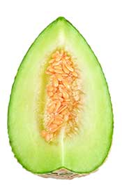

Sticking with the higher sugar fruits, melon is another sweet-tasting fleshy fruit.

Surprisingly, melons are—botanically speaking—a kind of berry. Not many people realize this since melons look quite a lot different to fruits like strawberries and blueberries!

There are many different types of the fruit, and they originate in Africa and South West Asia.

Since melons are juicy and refreshing, they enjoy popularity during the summer season.

Nutritionally, one cup of diced honeydew melon (170g) contains the following nutrients ([35](http://nutritiondata.self.com/facts/fruits-and-fruit-juices/1956/2));

* **Calories:** 61.2 kcal
* **Carbohydrate:** 15.5 g
* **Fiber:**1.4 g
* **Sugar:** 13.8 g
* **Fat:** 0.2 g
* **Protein:**0.9 g
* **Vitamin C:** 51% RDA
* **Potassium:** 11% RDA
* **Folate:** 8% RDA
* **Vitamin B6:** 7% RDA
* **Vitamin K:** 6% RDA

However, it is worth noting that [many varieties of melon exist](https://www.nutritionadvance.com/types-of-melons/), all with slightly different characteristics.

**34. Mulberry**

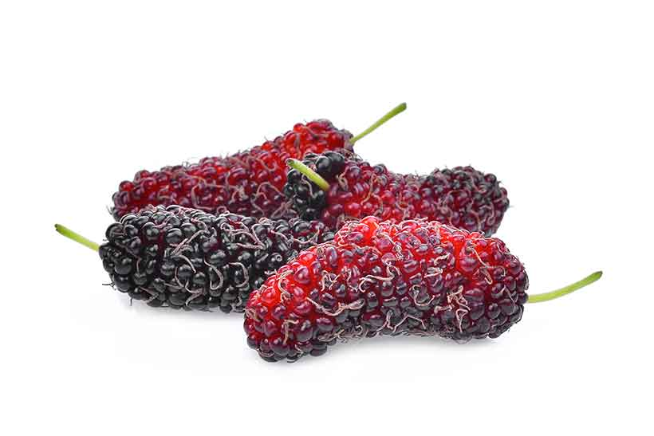

[Mulberries come in all shapes and sizes](https://www.nutritionadvance.com/mulberry-fruit-nutrition-benefits/), and they are a popular berry that grow around the world.

There are many different kinds of mulberry, but there are three main varieties; black, red, and white.

Black and red mulberries are native to the United States, while the white varieties mainly grow in China.

Mulberries are popular in fresh and dried form; black and red mulberries are sweet and juicy with a slightly tart flavor.

However, since white mulberries are predominantly from China, we usually buy them[in their dried state](http://amzn.to/2C7jJJ74eb5bd3cdb9262719effc025).

These berries are much smaller than the red and black varieties, and they have a much sweeter taste too.

Per cup of raw mulberries, the nutritional profile looks like this ([36](http://nutritiondata.self.com/facts/fruits-and-fruit-juices/1961/2));

* **Calories:** 60.2 kcal
* **Carbohydrate:** 13.7 g
* **Fiber:**2.4 g
* **Sugar:** 11.3 g
* **Fat:** 0.5 g
* **Protein:**2.0 g
* **Vitamin C:** 85% RDA
* **Vitamin K:** 14% RDA
* **Iron:** 14% RDA
* **Potassium:** 8% RDA
* **Vitamin B2:** 8% RDA

**35. Nectarines**

Nectarines are a popular fruit that is very closely related to peach.

The fruit has high water content and a sweet and juicy taste, which makes it a refreshing summer fruit.

A typical nectarine provides the following nutritional values ([37](https://fdc.nal.usda.gov/fdc-app.html#/food-details/169914/nutrients)):

* **Calories:** 63 kcal
* **Carbohydrate:** 15.1 g
* **Fiber:**2.4 g
* **Sugar:** 11.2 g
* **Fat:** 0.45 g
* **Protein:**1.5 g

[See this complete nutritional guide to nectarines for further information.](https://www.nutritionadvance.com/nectarines-nutrition-benefits/)

**36. Olives**

Most people don’t realize that olives are actually a fruit.

This is likely because olives don’t have that typical sweet flavor most fruits do, and they instead offer a source of healthy fats.

Personally, olives are one of my favorite foods – there are so many varieties and they all taste a little different. Despite the belief that there are only “green” and “black” olives, there are literally thousands of olive species.

It’s a common belief that they originated in Italy millions of years ago, and since that time olives spread around the Mediterranean region. In current times, olives grow throughout the world.

People mainly use olives for culinary purposes, as a snack, or to make olive oil. [Depending on the type of olive](https://www.nutritionadvance.com/types-of-olives/), they can taste anything from bitter and salty to slightly sweet.

Olives are one of the most polyphenol-rich foods, and they are widely known for their health benefits.

Per 100g, olives provide ([38](http://nutritiondata.self.com/facts/fruits-and-fruit-juices/1965/2));

* **Calories:** 81 kcal
* **Carbohydrate:** 5.6 g
* **Fiber:**2.5 g
* **Sugar:** 0g
* **Fat:** 6.9 g
* **Protein:**1.0 g
* **Sodium:** 37% RDA
* **Iron:** 18% RDA
* **Copper:** 11% RDA
* **Vitamin E:** 8% RDA
* **Vitamin A:** 7% RDA

**37. Orange**

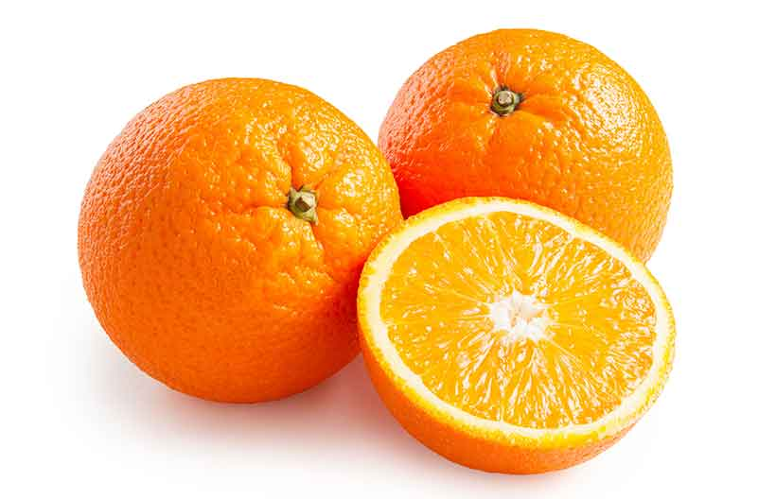

Oranges are among the most common fruit in the world.

The orange is a citrus fruit and, surprisingly, it is a hybrid rather than an original species. If you didn’t know about this point, then oranges are actually a hybrid of the pomelo and mandarin.

Oranges have a tough outer peel that encases the soft, juicy center. Generally speaking, the fruit has a sweet and (very slight) sour taste. However, there are hundreds of orange varieties and they can vary between sweet, bitter, and sour.

The sweet varieties are generally the edible kind we find in shops and in orange juice.

Oranges are a relatively high-carbohydrate fruit and they provide a decent amount of vitamin C.

One large orange supplies ([39](http://nutritiondata.self.com/facts/fruits-and-fruit-juices/1966/2));

* **Calories:** 86.5 kcal
* **Carbohydrate:** 78.8 g
* **Fiber:**4.4 g
* **Sugar:** 17.2 g
* **Fat:** 0.2 g
* **Protein:**1.7 g
* **Vitamin C:** 163% RDA
* **Folate:** 14% RDA
* **Vitamin B1:**11% RDA
* **Potassium:** 10% RDA
* **Vitamin A:** 8% RDA

For more information on oranges, see this in-depth guide:

[**10 Types of Oranges and Their Nutrition Facts**](https://www.nutritionadvance.com/types-of-oranges/)

**38. Papaya**

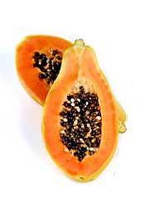

A tropical fruit with an exotic name; the papaya.

Papayas originate in Central America and grow in most countries with a tropical climate.

Despite previously being thought of as “exotic” they are now easy to find in most countries due to the global fruit trade.

The fruit has a smooth outer skin and a soft, reddish-orange flesh inside.

Papayas also have a striking appearance, and look like a cross between a giant pear and butternut squash. In terms of flavor, they are not dissimilar to mangoes but they are less sweet in nature.

Similar to most brightly colored fruits, they contain a wealth of polyphenols, and they provide the following nutrients per cup (140g) ([40](http://nutritiondata.self.com/facts/fruits-and-fruit-juices/1985/2));

* **Calories:** 54.6 kcal
* **Carbohydrate:** 13.7 g
* **Fiber:**2.5 g
* **Sugar:** 8.3 g
* **Fat:** 0.2 g
* **Protein:**0.9 g
* **Vitamin C:** 144% RDA
* **Vitamin A:** 31% RDA
* **Folate:** 13% RDA
* **Potassium:** 10% RDA
* **Vitamin E:** 5% RDA

[Find out more in this full guide to the nutritional values and benefits of papaya.](https://www.nutritionadvance.com/papaya-nutrition-benefits/)

**39. Passion Fruit**

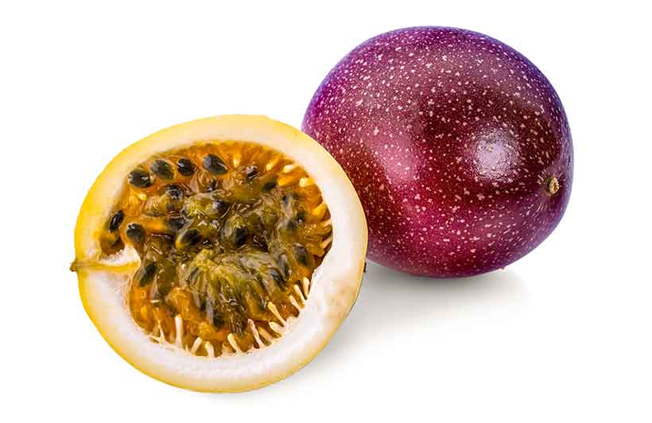

Passion fruit is another tropical fruit (technically a berry) that is native to the South American region, believed to originate in Brazil, Paraguay, and Argentina.

Cultivation of the fruit now happens throughout the tropical and subtropical regions of the world.

Passion fruit is one of the more unique fruits, and it is about the size of a golf ball. A hard, brown outer shell surrounds a yellow, gelatinous sticky, and sweet flesh.

This sweet pulp is comparable to tomatoes; it is very juicy and contains lots of edible seeds.

However, there are many different varieties of passion fruit, and some (such as the ‘golden passion fruit’) are the size of a large grapefruit.

Despite passion fruit being one of the higher-carb fruits, about 50% of these carbs come from fiber.

Per 5-fruit serving, passion fruit contributes the following nutrients ([41](http://nutritiondata.self.com/facts/fruits-and-fruit-juices/1987/2));

* **Calories:** 88 kcal
* **Carbohydrate:** 21 g
* **Fiber:**9.5 g
* **Sugar:** 2.0 g
* **Fat:** 0.1 g
* **Protein:**0.4 g
* **Vitamin C:** 45% RDA
* **Vitamin A:** 25% RDA
* **Potassium:**10% RDA
* **Iron:** 10% RDA
* **Phosphorus:** 5% RDA

**40. Pear**

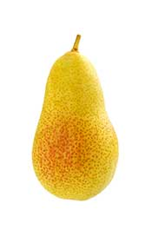

Pears are a delicious, sweet, and juicy fruit.

They grow naturally all around the world, but their origin, like many other fruits, lies in China.

There are so many different types of pear in the world, ranging from the classic “pear-shaped” European species to the large, round Chinese/Korean pear.

However, all pears share the same thin, crisp skin, and sweet, juicy white flesh.

Pears have the sweetness of an apple mixed with a kind of mild, citrus-like flavor and smell.

The flesh is crunchy as you bite into it, with a large amount of water locked inside.

In fact, pears are around 84% water content by weight, giving them one of the highest water content out of all fruits ([42](https://www.medicalnewstoday.com/articles/285430.php)).

The nutritional content of pears offers a decent range of vitamins and minerals, but it is not particularly high in any specific nutrient.

Here is the profile of a medium-sized pear ([43](http://nutritiondata.self.com/facts/fruits-and-fruit-juices/2005/2));

* **Calories:** 103 kcal
* **Carbohydrate:** 27.5 g
* **Fiber:**5.5 g
* **Sugar:** 17.4 g
* **Fat:** 0.2 g
* **Protein:**0.7 g
* **Vitamin C:** 14% RDA
* **Vitamin K:** 10% RDA
* **Copper:** 7% RDA
* **Potassium:** 6% RDA
* **Manganese:** 4% RDA

**41. Persimmon**

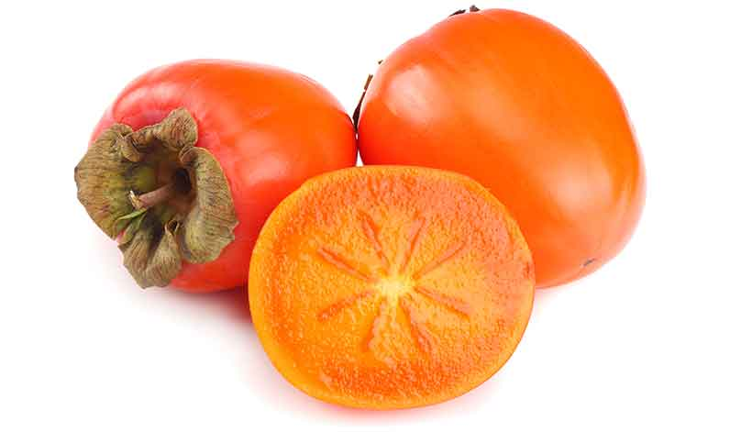

Persimmons are a commonly available fruit and the typical cultivars are native to East Asia; particularly China, Japan, and Korea.

The persimmon fruit is a brilliant bright orange color, and it comes in two distinct varieties.

First, the fuyu persimmon looks like a wide-shaped tomato and it has a crisp, slightly sweet and crunchy flesh.

Secondly, the Hachiya persimmon has a rounder and taller shape. This particular persimmon has a firm, solid feel while it is fresh and tastes incredibly bitter. As a result, they shouldn’t be eaten until they are fully ripe.

When ripe, the fruit becomes extremely soft, and squeezing the fruit should feel like there are large amounts of water inside. Typically, this kind of persimmon is eaten with a spoon since it’s so soft.

Like most orange plant foods, persimmons are a good provider of vitamin A in the form of beta-carotene ([44)](http://nutritiondata.self.com/facts/fruits-and-fruit-juices/2016/2). Per fruit;

* **Calories:** 118 kcal
* **Carbohydrate:** 31.2 g
* **Fiber:**6g
* **Sugar:** 21 g
* **Fat:** 0.3 g
* **Protein:**1.0 g
* **Vitamin A:** 55% RDA
* **Manganese:** 30% RDA
* **Vitamin C:** 21% RDA
* **Copper:** 9% RDA
* **Vitamin B6:** 8% RDA

**42. Pineapple**

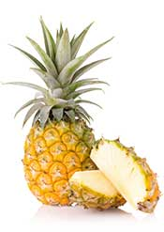

Pineapples are a sweet and slightly sour tropical fruit originating from South America.

It is now very common in tropical regions of the world such as the Philippines and the Caribbean.

Pineapples have a firm yellow flesh that supplies a juicy, sweet taste.

Similar to other tropical fruits, pineapples have many culinary uses. For instance, they’re a popular choice in juices, smoothies, desserts, and even pizzas.

Pineapples are very rich in vitamin C and the mineral manganese. Per cup (165g) serving, pineapples provide ([45](http://nutritiondata.self.com/facts/fruits-and-fruit-juices/2019/2));

* **Calories:** 82.5 kcal
* **Carbohydrate:** 21.6 g
* **Fiber:**2.3 g
* **Sugar:** 16.3 g
* **Fat:** 0.2 g
* **Protein:**0.9 g
* **Vitamin C:** 131% RDA
* **Manganese:** 76% RDA
* **Vitamin B1:** 9% RDA
* **Vitamin B6:** 9% RDA
* **Copper:** 9% RDA

**43. Plum**

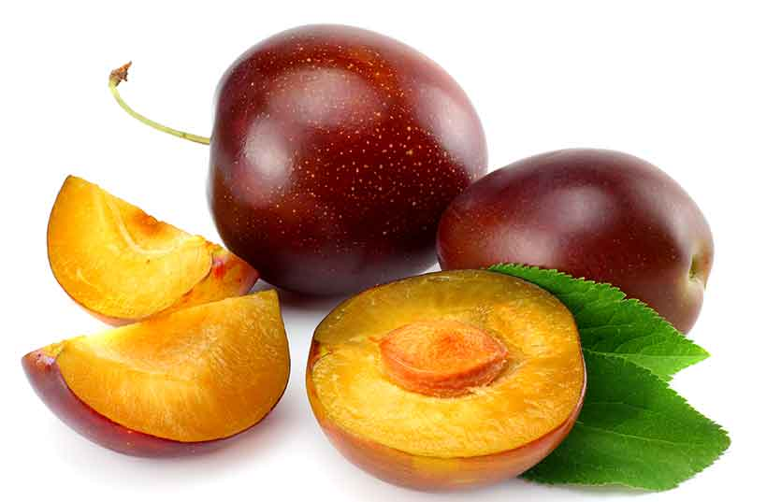

Plums are small and round [purple fruit](https://www.nutritionadvance.com/purple-fruits/) that have origins in China.

Appearance wise, a dark purple skin surrounds the juicy flesh, which can range from yellow-orange to reddish-purple in color.

Plums can either be eaten fresh or in their dried state, which is called a ‘prune’.

The taste of plums differs depending on the variety and degree of ripeness. While ripe plums tend to be sweet, an unripe plum can taste incredibly tart.

Plums are one of the most polyphenol-rich fruits, and randomized controlled trials suggest they can help protect against bone loss ([46](https://www.ncbi.nlm.nih.gov/pmc/articles/PMC5409740/).

The nutritional profile of one plum is below ([47](http://nutritiondata.self.com/facts/fruits-and-fruit-juices/2032/2));

* **Calories:** 30.4 kcal
* **Carbohydrate:** 7.5 g
* **Fiber:**0.9 g
* **Sugar:** 6.5 g
* **Fat:** 0.2 g
* **Protein:**0.5 g
* **Vitamin C:** 10% RDA
* **Vitamin A:** 5% RDA
* **Vitamin K:** 5% RDA
* **Potassium:** 3% RDA
* **Copper:** 2% RDA

**44. Pomegranate**

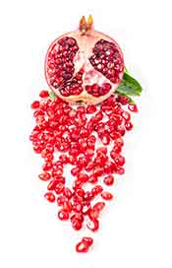

Pomegranates are unique in appearance and taste.

They are believed to have originated in the India to Middle-East region, and they’ve long been cultivated in the Middle East and Mediterranean region.

Nowadays, pomegranate cultivation is prevalent throughout dry and hot regions in the world.

This interesting variety of fruit has a thick and firm red skin.

Inside the pomegranate, we can find hundreds of red edible seeds (known as arils) separated into different chambers by a white stringy material called albedo.

Pomegranates are a healthy fruit that is high in fiber, vitamins, and minerals; per fruit they offer ([48](http://nutritiondata.self.com/facts/fruits-and-fruit-juices/2038/2));

* **Calories:** 234 kcal
* **Carbohydrate:** 52.7 g
* **Fiber:**11.3 g
* **Sugar:** 38.5 g
* **Fat:** 3.3 g
* **Protein:**4.7 g
* **Vitamin C:** 58% RDA
* **Potassium:** 48% RDA
* **Manganese:** 27% RDA
* **Vitamin B6:** 22% RDA
* **Vitamin B2:** 19% RDA

[For further information, see this full nutritional guide to pomegranate.](https://www.nutritionadvance.com/pomegranate-nutrition/)

**45. Pomelo**

Pomelo is the largest citrus fruit and provides a significant vitamin C level.

A typical pomelo fruit weighs 609 grams and provides the following nutritional profile ([49](https://fdc.nal.usda.gov/fdc-app.html#/food-details/167754/nutrients)):

* Calories: 231 kcal
* Carbohydrates: 58.6 g
* Fiber: 6.09 g
* Fat: 0.24 g
* Protein: 4.63 g

For the full values, see this [guide to pomelo and its nutritional benefits](https://www.nutritionadvance.com/pomelo-nutrition-benefits/).

**46. Rambutan**

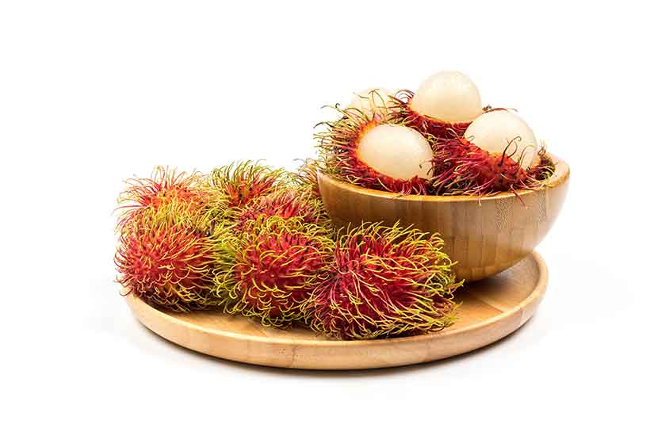

[Rambutan](https://www.nutritionadvance.com/rambutan-fruit/) comes from the tropical regions in South-East Asia, particularly Malaysia and Indonesia.

The rambutan is also one of the strangest looking fruits in the world.

In fact, it looks like it comes from another planet! This fruit has a bright red outer skin that is covered in red and green spiky hairs.

While the skin feels dry and leathery, the flesh inside is soft, white and round, and contains a large seed in the middle.

Rambutan have a slightly similar taste as lychee, but they are sweeter and slightly less juicy.

Per 100g, rambutan provides ([50](https://www.healwithfood.org/nutrition-facts/rambutan-fruit-health-benefits.php), [51](http://nutritiondata.self.com/facts/custom/665008/2?print=true));

* **Calories:** 68 kcal
* **Carbohydrate:** 16 g
* **Fiber:**2.8 g
* **Sugar:** 13.2 g
* **Fat:** 0.3 g
* **Protein:**0.9 g
* **Vitamin C:** 66% RDA
* **Manganese:** 10% RDA
* **Copper:** 9% RDA
* **Potassium:** 5% RDA
* **Magnesium:** 4% RDA

**47. Raspberry**

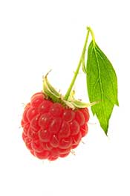

Raspberries are one of the most commonly cultivated fruits in the world and they grow in temperate regions.

This variety of fruit has dozens of different cultivars so raspberries can differ in appearance depending on the country.

Raspberries grow on raspberry bushes and the fruit itself is composed of dozens of small drupelets.

The raspberry has a soft flesh with a slightly sweet and juicy taste.

As a species of berry, [raspberries are very high in polyphenols](https://www.nutritionadvance.com/red-raspberries-nutrition-benefits/), and they also provide ample amounts of vitamin C and manganese.

Per cup (123g) raspberries offer ([52](http://nutritiondata.self.com/facts/fruits-and-fruit-juices/2053/2));

* **Calories:** 64 kcal
* **Carbohydrate:** 14.7 g
* **Fiber:**8.0 g
* **Sugar:** 5.4 g
* **Fat:** 0.8 g
* **Protein:**1.5 g
* **Vitamin C:** 54% RDA
* **Manganese:** 41% RDA
* **Vitamin K:** 12% RDA
* **Magnesium:** 7% RDA
* **Folate:** 6% RDA

**48. Redberries**

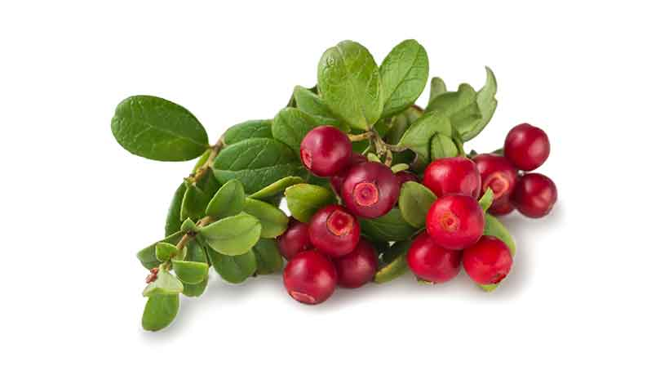

The name ‘redberry’ is often used to refer to lingonberries.

In fact, there are dozens of names for this berry depending on the region. For example, you may see the names ‘mountain cranberry’, ‘red whortleberry’, ‘cowberry’, and ‘foxberry’.

The berries are common across Europe and Northern America, and they tend to have a tart taste. As a result, we can find the berries in many sweetened jams, juices and desserts.

Per cup, redberries supply ([53](https://www.fatsecret.com/calories-nutrition/generic/swedish-lingonberries));

* **Calories:** 71 kcal
* **Carbohydrate:** 16.3 g
* **Fiber:**3.7 g
* **Sugar:** 8.3 g
* **Fat:** 0.5 g
* **Protein:**1.1 g
* **Vitamin C**: 72% RDA
* **Iron:**4% RDA
* **Calcium:** 3% RDA
* **Vitamin A:** 3% RDA

**49. Rhubarb**

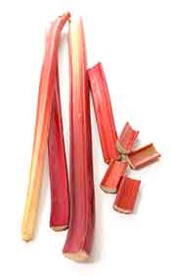

The origin of rhubarb is disputed, but it now grows throughout much of the world.

The rhubarb plant grows large leaves—which are poisonous—and long, edible stems.

Technically, rhubarb is not a fruit at all and it is actually a vegetable. However, since it is commonly thought of as a fruit (and used like one), this guide features it.

Rhubarb has a strong sour taste; it is extremely tart, and it features in many sweetened desserts.

Notably, rhubarb has a long history of medicinal use. Specifically, it is a strong laxative and may help treat constipation. However, it may also cause stomach distress in some susceptible people ([54](https://www.ncbi.nlm.nih.gov/pmc/articles/PMC4389350/)).

Nutritionally, one cup (122g) of rhubarb supplies ([55](http://nutritiondata.self.com/facts/fruits-and-fruit-juices/2056/2));

* **Calories:** 25.6 kcal
* **Carbohydrate:** 5.5 g
* **Fiber:**2.2g
* **Sugar:** 1.3 g
* **Fat:** 0.2 g
* **Protein:**1.1 g
* **Vitamin K:** 45% RDA
* **Vitamin C:** 16% RDA
* **Manganese:** 12% RDA
* **Potassium:** 10% RDA
* **Calcium:** 10% RDA

**50. Starfruit**

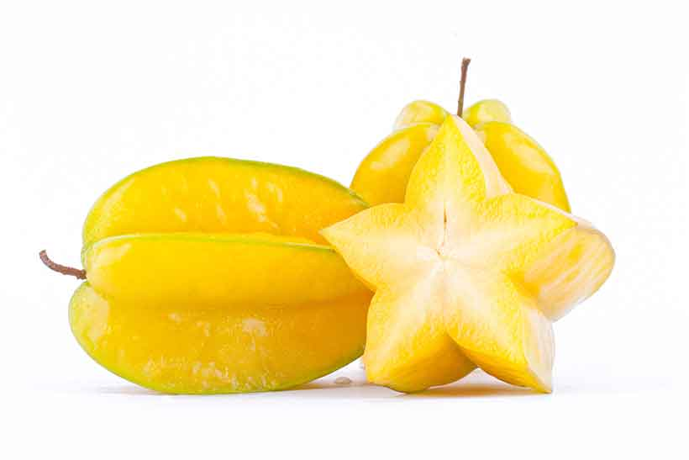

[Starfruit](https://www.nutritionadvance.com/star-fruit-nutrition-benefits/) is one of the most visually appealing fruits. When you slice the fruit, each slice looks like a bright yellow star.

It is a tropical fruit that is native to South and South-East Asia, and it has a sweet and tart taste.

The flesh is firm, and its color ranges from green to a deep, bright yellow when fully ripe.

Starfruit is more than 90% water by weight, making it one of the best fruits for hydration.

Although the fruit is healthy and contains a good nutrient profile, it can be dangerous to those with kidney problems. It should not be eaten by anyone with chronic kidney disease ([56](https://www.ncbi.nlm.nih.gov/pubmed/26154645)).

The overall nutritional profile of one starfruit is as follows ([57](http://nutritiondata.self.com/facts/fruits-and-fruit-juices/1858/2));

* **Calories:** 28.2 kcal
* **Carbohydrate:** 6.2 g
* **Fiber:**2.5 g
* **Sugar:** 3.6 g
* **Fat:** 0.3 g
* **Protein:**0.9 g
* **Vitamin C:** 52% RDA
* **Copper:** 6% RDA
* **Vitamin B5:** 4% RDA
* **Folate:**3% RDA
* **Potassium:**3% RDA

**51. Strawberry**

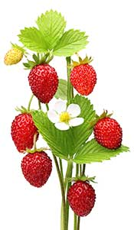

The strawberry is one of the most common (and beloved) fruits in the world.

Strawberries are thought to be berries, but this is not botanically true, and they are an accessory fruit.

Commonly eaten fresh, with cream, or in a range of desserts, strawberries are a soft and sweet-tasting fruit.

In addition to their taste, strawberries actually smell sweet too – if that is possible.

Given this, strawberry flavors and scents are prevalent in candy, soaps, creams, lip balms and many other products.

[Strawberries have an excellent nutrition profile](https://www.nutritionadvance.com/strawberries-nutrition-benefits/) and contain large amounts of vitamin C. One cup (152g) of the fruit provides ([58](http://nutritiondata.self.com/facts/fruits-and-fruit-juices/2064/2));

* **Calories:** 48.6 kcal
* **Carbohydrate:** 11.7 g
* **Fiber:**3 g
* **Sugar:** 7.4 g
* **Fat:** 0.5 g
* **Protein:**01.0 g
* **Vitamin C:** 149% RDA
* **Manganese:** 29% RDA
* **Folate:** 9% RDA
* **Potassium:** 7% RDA
* **Magnesium:** 5% RDA

**52. Tangerine**

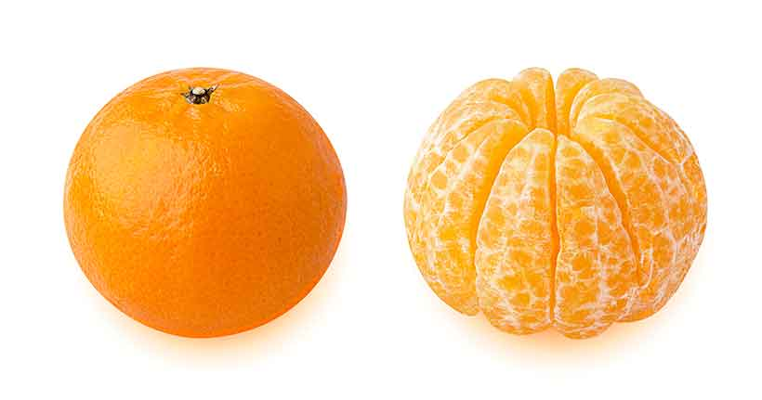

While sharing a similar taste, tangerines are a smaller size than oranges, and they are less round (flatter) in shape.

However, they have a bigger taste – tangerines are sweeter and more flavorful than regular oranges.

The tangerine also has a softer skin which is easier to peel, and this makes them an easy snack for when you’re out of the house.

Tangerines are high in vitamin C and contain small amounts of most other micronutrients.

One medium-sized tangerine offers ([59](http://nutritiondata.self.com/facts/fruits-and-fruit-juices/1978/2));

* **Calories:** 46.6 kcal
* **Carbohydrate:** 11.7 g
* **Fiber:**2.8 g
* **Sugar:** 21.8 g
* **Fat:** 0.3 g
* **Protein:**0.7 g
* **Vitamin C:** 39% RDA
* **Vitamin A:** 12% RDA
* **Potassium:** 4% RDA
* **Folate:** 4% RDA
* **Calcium:** 3% RDA

**53. Ugli Fruit**

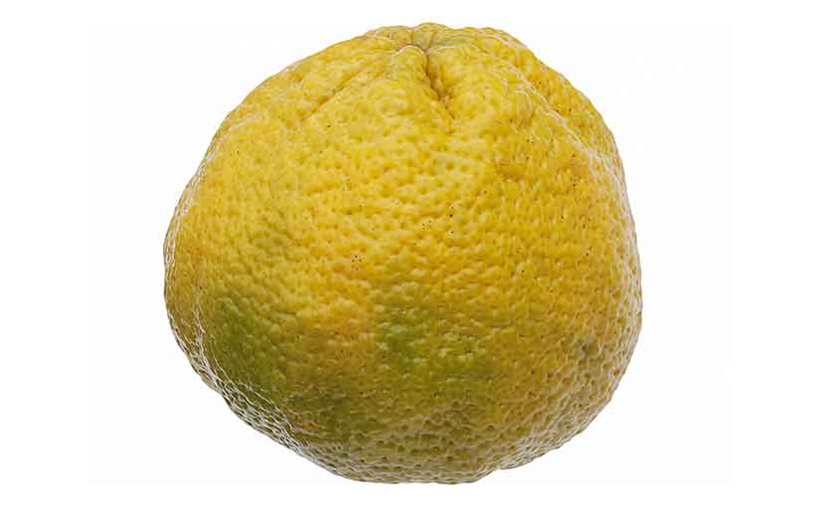

Ugli fruit is a unique hybrid fruit originating in Jamaica where it was discovered in 1924.

Interestingly, the fruit is a cross between an orange, grapefruit, and tangerine.

Despite the name, the ugli fruit isn’t the worst-looking fruit in the world; it just looks a little dull.

However, inside the tough and thick greenish-yellow skin, there is a bright orange flesh.

Ugli fruits are very juicy and sweet and taste somewhat like a slightly more sour orange.

Nutritionally, one ugli fruit provides ([60](http://www.myfitnesspal.com/food/calories/ugli-ugli-fruit-463354248));

* **Calories:** 90 kcal
* **Carbohydrate:** 22 g
* **Fiber:**4 g
* **Sugar:** 16 g
* **Fat:** 0 g
* **Protein:**2 g
* **Vitamin C:** 140% RDA
* **Calcium:** 4% RDA

**54. Watermelon**

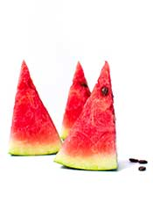

The origin of watermelons is Southern Africa, and it is a large fruit that grows in tropical and subtropical regions.

As you might guess from the name, watermelons are another fruit with a high water content; 91.5% to be exact.

The fruit can wildly vary in size, with some fruit being a few kilograms in weight, but others reaching gigantic proportions.

Apparently, the [largest watermelon on record](https://en.wikipedia.org/wiki/Watermelon#Varieties) was from Tennessee and weighed in at 159kg (351 pounds).

Watermelons taste sweet and juicy, and provide the following nutrients per cup (154g) ([61](http://nutritiondata.self.com/facts/fruits-and-fruit-juices/2072/2));

* **Calories:** 46.2 kcal
* **Carbohydrate:** 11.6 g
* **Fiber:**0.6 g
* **Sugar:** 9.5 g
* **Fat:** 0.2 g
* **Protein:**0.9 g
* **Vitamin C:** 21% RDA
* **Vitamin A:** 18% RDA
* **Potassium:** 5% RDA
* **Magnesium:** 4% RDA
* **Vitamin B5:** 3% RDA

And that marks the end of this guide to 50 different types of fruit.

